**Mini Project report on**

**FOOD GUARD PRO**

**Submitted by**

# JERRY GEORGE ANTONY



**Focus on Excellence**

**Department of Electronics & Communication Engineering**

## FEDERAL INSTITUTE OF SCIENCE AND TECHNOLOGY (FISAT)®

**Angamaly-683577, Ernakulam**

Affiliated to

## APJ ABDUL KALAM TECHNOLOGICAL UNIVERSITY

Thiruvananthapuram-695016

**2024**

**Mini Project report on**

**FOOD GUARD PRO**

**Submitted by**

# JERRY GEORGE ANTONY



**Focus on Excellence**

**Department of Electronics & Communication Engineering**

## FEDERAL INSTITUTE OF SCIENCE AND TECHNOLOGY (FISAT)®

**Angamaly-683577, Ernakulam**

Affiliated to

## APJ ABDUL KALAM TECHNOLOGICAL UNIVERSITY

Thiruvananthapuram-695016

**2024**

### FEDERAL INSTITUTE OF SCIENCE AND TECHNOLOGY (FISAT) ®

Mookkannoor(P.O), Angamaly-683577



**Focus on Excellence**

**CERTIFICATE**

This is to certify that the Mini project report titled **Food Guard Pro** submitted by **Jerry George Antony,** towards partial fulfillment of the requirements for the award of the degree of **Bachelor of Technology** in Electronics and Communication Engineering is a record of bonafide work carried out by them during the academic year 2022.

|  |  |
| --- | --- |
| Project Guide | Head of the Department |
| Internal Examiner | External Examiner |

Place:Mookkannoor

Date:

**ACKNOWLEDGEMENT**

We would like to express our sincere gratitude to all those who helped in the proper and timely completion of our project. I respect and thank **Dr. Jacob Thomas V**. our Principal and **Dr. S Krishna Kumar**, The Head of the Department, Dept. of Electronics and Communication Engineering for their necessary help in the fulfilment of this project.

We owe our deep gratitude to our project guide **Mrs.Nisha R**, Assistant Professor of Electronics and Communication Department for providing encouragement, constant support, and guidance which were of great help to complete this project successfully. We are also thankful to one and all faculty members of the Department of Electronics and Communication Engineering for their guidance and wholehearted support. Their effort and sincerity will always be remembered in our hearts.

We also wish to thank our parents for financing our studies in this college as well as for constantly encouraging us to learn about engineering. Their sacrifice in providing this opportunity to learn engineering is gratefully acknowledged.

**ABSTRACT**

*In recent years, the demand for portable and energy-efficient refrigeration solutions has increased significantly. This paper presents the design and development of a smart refrigerator tailored for portable purposes, integrating advanced features such as a methane gas detector and load cells to enhance food preservation and provide real-time storage information. Furthermore, the incorporation of load cells into the refrigerator's structure enables the monitoring of storage conditions, such as weight and distribution of items within the appliance. This information is relayed to a dedicated mobile application, allowing users to track and manage their food inventory in real-time. Key features of the small smart refrigerator include a compact and lightweight design, low power consumption, and a user-friendly interface. The methane gas detector utilizes advanced sensor technology to promptly detect any gas leakage, triggering alarms and notifications to alert users. The load cells are strategically placed within the refrigerator to accurately measure and relay storage information without compromising the overall functionality of the appliance. This innovative approach to portable refrigeration not only addresses the common challenges associated with food preservation during travel but also promotes sustainability by reducing food waste and energy consumption. The smart refrigerator with methane gas detection and load cell integration represents a significant advancement in portable refrigeration technology, offering users a reliable and efficient solution for preserving perishable items while on the move*.

**LIST OF FIGURES**

**Fig. No. Fig. Name**  **Page No.**

4.1 Block Diagram of Arduino 16

4.2 Block Diagram of Peltier 16

9.1 Introduction Message 30

9.2 Main Interface 30

9.3 Food Storage Display 31

9.4 Food Spoilage Display 31

**LIST OF TABLES**

**Table. No. Table. Name**  **Page No.**

8.1 Cost Estimation 21

**ABBREVIATIONS**

IOT: Internet of Things

GSM: Global System for Mobile Communication

LCD: Liquid Crystal Display

DHT: Digital Temperature and Humidity sensor

**CONTENTS**

**Page No**

**Chapter 1 INTRODUCTION 10**

**1.1 OBJECTIVES**  **10**

### 1.2 SCOPE OF PROJECT 11

**Chapter 2 LITERATURE SURVEY**  **12**

**2.1 Smart Refrigerator based on ‘Internet Of Things’.** **12**

**2.2 The Implementation of IOT based Smart Refrigerator System** **13**

**2.3 Eco-Friendly Refrigerator using Peltier Device.** **14**

**2.4 The Implementation of A GSM Based User-Machine Interacted**  **15**

**Refrigerator**

**Chapter 3 METHODOLOGY 16**

**Chapter 4 BLOCK DIAGRAM 17**

**Chapter 5 FLOW CHART 18**

**Chapter 6 HARDWARE COMPONENTS 19**

**Chapter 7 SOFTWARE USED** **27**

**Chapter 8 COST ESTIMATION 28**

## Chapter 9 RESULTS 29

## **Chapter 10 CONCLUSION 31**

**Chapter 11 REFERENCES 32**

**Chapter 1**

**INTRODUCTION**

The refrigerator is the most frequently used kitchen electrical appliance all over the world for food storage. Here we discover the smart refrigerator that not only keeps your food fresh but is also equipped with cutting edge technology to detect and prevent spoilage. Our smart refrigerator takes innovation to the next level with automated food storage detection. It keeps track of your inventory and provides updates on the status of each item. Embrace a touchless and convenient experience with the automatic door feature. Our smart refrigerator takes portability to new heights. Its compact design makes it a versatile solution for various living spaces. With features like food spoilage detection, food storage management, and a user-friendly automatic door, it creates a simplified lifestyle.

**1.1 OBJECTIVES**

The vision for our smart refrigerator is to revolutionize food management, prioritizing efficiency and sustainability. We've meticulously designed it with a suite of features to address various aspects of food preservation and consumption. Its compact size and portability make it adaptable to any living space, ensuring accessibility for all users. Equipped with sensors to monitor temperature and weight, it seamlessly integrates data into its program, facilitating precise storage conditions. An automatic door enhances user experience, ensuring smooth operation. Most importantly, our refrigerator is programmed to detect spoilage or food shortage, promptly alerting users via mobile notifications. This proactive approach not only minimizes food wastage but also fosters a culture of conscientious consumption. With every aspect meticulously crafted, our smart refrigerator is an embodiment of innovation and practicality, poised to redefine how we interact with our food.

**1.2 SCOPE OF PROJECT**

Smart fridges can help you minimize your impact on the planet and your wallet. With more fresh ingredients available, people could experiment with new recipes and discover new things. It also helps to reduce our electricity consumption, save on groceries and prevent maintenance problems. Food Waste Reduction helps minimize food wastage by alerting users when food is nearing expiration or spoilage, promoting more efficient consumption habits. By monitoring food storage conditions, it encourages healthier eating habits as users are more aware of the freshness of their food. It can potentially save users money by reducing the amount of food that gets thrown away due to spoilage. By reducing food waste, it indirectly contributes to lower greenhouse gas emissions associated with food production and disposal. For individuals with busy lifestyles, having a smart refrigerator that manages food freshness can save time and effort spent on monitoring expiration dates manually. It can be particularly beneficial for elderly individuals or those with disabilities who may have difficulty keeping track of food freshness, promoting independence and health. Overall, a mini smart refrigerator with food spoilage and storage detection aligns with societal goals of reducing waste, promoting healthier living, and enhancing convenience.

**Chapter 2**

**LITERATURE SURVEY**

**2.1 Smart Refrigerator based on ‘Internet of Things’**

In this paper they have developed a smart refrigerator that will work on namely two constraints- temperature and weight. The proposed model detects the quantity of food items left in the refrigerator to the users using a mobile application. It tells the user about the shortage of food and the temperature of the refrigerator by which the wastage of energy also can be saved due to automatic control. Here they have used analogue sensor for measuring temperature. A 5 kg strain gauge load cell is used to measure the quantity of food item present in the refrigerator in analogue form which is then fed into HX711 (A to D converter) to get the weight in digital form. A thermistor of 10 ohms is connected to the Arduino to measure the temperature of the refrigerator. A mobile application is developed to notify the user regarding the food items left and to notify about the temperature of the refrigerator. The user can check the weight of the items left and can order food online if it falls short. The user can also check the temperature of the items in the refrigerator. The focus here is to develop a weight and temperature monitoring system and a mobile application to notify the user about the latter.

ADVANTAGES:

* It helps the user to know about the quantity of food and the temperature.

DISADVANTAGES:

* Not able to detect the freshness of food items.

**2.2 The Implementation of IOT based Smart Refrigerator System**

Combining the idea of Internet of Things and smart kitchen evolution, the smart refrigerator system is developed. The system consists of three main parts which are sensing module, control module and transmission module. Sensing modules consist of load cell and Oduor sensor while control module consists of Arduino uno and power supply unit and last but not least the transmission module consists of lcd module and Wi-Fi module. These modules work together to determine contents status inside the refrigerator and notify the user about the condition and the quantity of the food via an SMS or an email. MQ3 gas sensor is used to detect gases produced by fruits or vegetables or any other organic contents stored in the refrigerator. There is a possibility that a variety of foods are kept in the refrigerator at different times. Therefore, the latest food kept in the refrigerator is the latest to become rotten or expired. However, due to the mixture of gases produced by the earliest food kept in the refrigerator, it also may affect the latest to become rotten faster than it supposed to be. To prevent this problem and maintain the quality and freshness of the contents inside the refrigerator, a gas sensor is used. In addition to MQ3 sensor, DHT-Il temperature and humidity sensor is used to monitor the temperature and humidity of the refrigerator. The reason is temperature plays an important role in maintaining the freshness of the food. The normal range temperature for refrigerator should be at or below 40° F (4° C). Therefore, with humidity measurement and temperature measurement range between 20 percent until 95 percent and between 0° C to 60° C respectively

ADVANTAGES:

* Cost effective and time-consuming solution. Can be used for home automation and restaurant management.

DISADVANTAGES:

* Not able to implement automatic door.

**2.3 Eco-Friendly Refrigerator using Peltier Device.**

The refrigerators available in the market uses compressors and hazardous cooling vapors for refrigeration purposes. These vapors are harmful for the atmosphere and due to the use of compressors it calls for more electricity, so an eco-friendly refrigerator is essential. Thus, the concept of creating eco-friendly refrigerator using Peltier module. Peltier is mainly a transducer or thermoelectric device. When a 12V supply is applied to this device, one side of this device dissipates heat, and the other side becomes cool (temperature depends upon the specifications of Peltier). Using a heat sink with a fan, heat dissipated by Peltier is vented out in order to safeguard the device from any kind of damage. In this way, Peltier is used for refrigeration or cooling purpose. The objective of this project is to make refrigeration eco-friendly by avoiding harmful gases and as consumption of electricity is reduced, making the device economical. A device called Peltier is the vital device of this project, due to which, there's no requirement of compressor or CFC gases. The Peltier module generates the Peltier effect and it's used for both heating as well as cooling purposes. So, we can use Peltier module in the current system to boost the performance or COP (Coefficient of Performance) of the system.

ADVANTAGES:

* It is environmentally friendly, transportable and cost effective.
* Pollution apprehension of conventional cooling system.

DISADVANTAGES:

* Not able to lower the cooling temperature below 6 degrees Celsius.

**2.4 The Implementation of A GSM Based User-Machine Interacted Refrigerator**

In the project, human-machine interaction has been targeted by using the refrigerator. For this purpose, a mini fridge was designed as a prototype to be monitored remotely by retrieving data through a GSM module and various sensors. The system consists of micro-controller card, GSM module, 1/0 card, LCD display, sensors and battery mounted on the mini fridge. GSM queries can be made by text message or a phone call to the SIM card number located in the GSM module. Also, notifications about the number of products contained in the mini fridge, freezer and cooler side temperatures, and power outages in uncertain situations have been conducted. The system mounted in the fridge consists of microcontroller card, GSM modem, 1/0 card, LCD card, power supply card, sensors and accumulator. It is sold at a very low cost (Almost 100S. This amount will drop more in series production. Ability of operation with all GSM systems. Ability of operation with all mobile phone systems. It does not require internet. Hence, the proposed system contains many innovations and improvements when considered as a whole. Current commercial products are upper class refrigerators like Smart Thinq Refrigerator [21], which generally requires internet, smart phones, and works with new GSM systems. Therefore, they are addressed to higher-income and limited community as luxury consumer goods. Whereas, in the proposed system, the target of home automation with the mentioned features has been accomplished in an inexpensive way. However, the project can easily be used in larger refrigerators and cooling systems. The developed GSM based technology is also applicable on other household white goods to make life easier.

ADVANTAGES:

* Able to give the contents and temperature data in power outage term.
* Able to operate all mobile phone systems.
* Does not require internet.

**Chapter 3**

**METHODOLOGY**

Arduino is where all the sensors are connected. Project contains both hardware construction and software programming. Load cells collect data about the storage of the food and alert the user if the weight becomes less than a certain quantity. Methane gas detectors help in alerting about spoiled food also. For performing the automatic door operation, with the help of a servo motor an ultrasonic sensor is used. Peltier kit performs the operation of cooling and temperature sensor helps in displaying the data on LCD display. GSM Module helps in sending message alerts to the user's mobile phone. LCD display helps in displaying information to the user. Temperature sensor also helps in keeping the data of temperature inside refrigerator. Ultrasonic sensors also help in detecting the presence of a person. Project contains both hardware construction and software programming that together builds up the refrigerator.

**Chapter 4**

**BLOCK DIAGRAM**

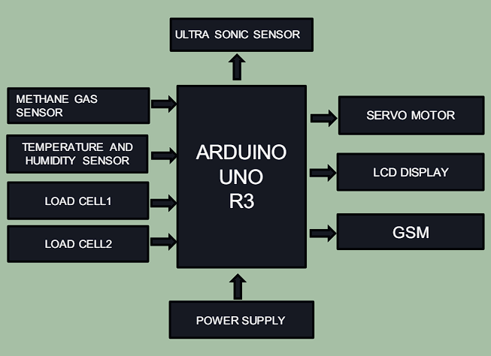

Fig 4.1 Block Diagram Of Arduino

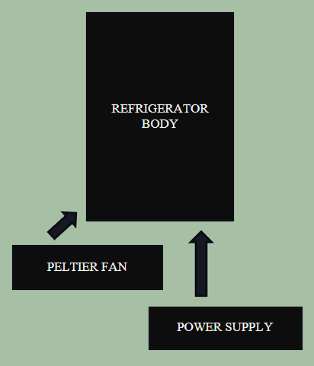

Fig 4.2 Block Diagram Of Peltier

**Chapter 5**

**FLOW CHART**

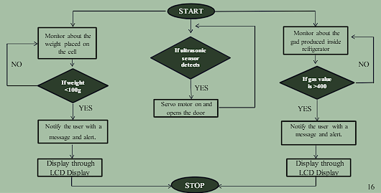

**Chapter 6**

**HARDWARE COMPONENTS**

**6.1 Arduino UNO**

Arduino UNO is a low-cost, flexible, and easy-to-use programmable open-source microcontroller board that can be integrated into a variety of electronic projects. This board can be interfaced with other Arduino boards, Arduino shields, Raspberry Pi boards and can control relays, LEDs, servos, and motors as an output. Arduino UNO features AVR microcontroller Atmega328, 6 analogue input pins, and 14 digital I/O pins out of which 6 are used as PWM output. This board contains a USB interface i.e. USB cable is used to connect the board with the computer and Arduino IDE (Integrated Development Environment) software is used to program the board. The unit comes with 32KB flash memory that is used to store the number of instructions while the SRAM is 2KB and EEPROM is 1KB. The operating voltage of the unit is 5V which projects the microcontroller on the board and its associated circuitry operates at 5V while the input voltage ranges between 6V to 20V and the recommended input voltage ranges from 7V to 12V.

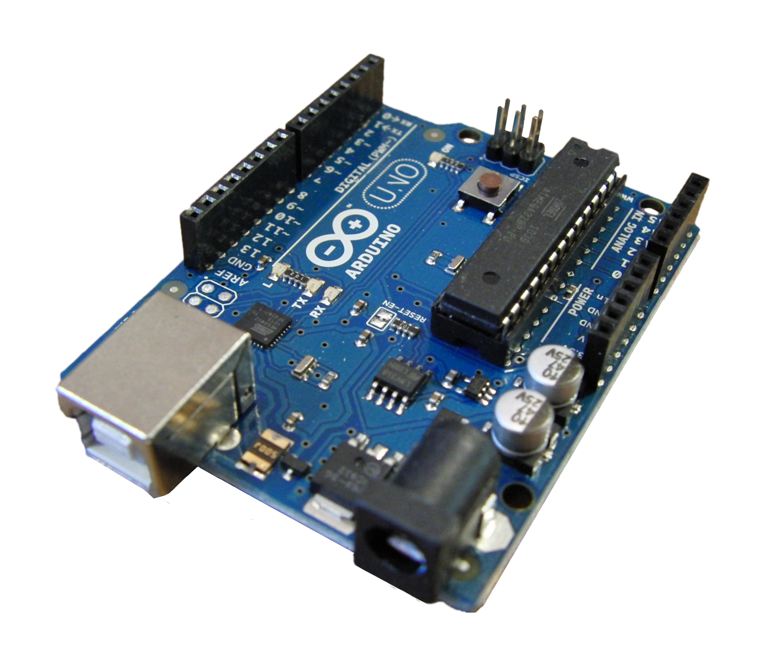

**6.2 Ultrasonic Sensor**

An HC-SR04 ultrasonic distance sensor actually consists of two ultrasonic transducers. One acts as a transmitter that converts the electrical signal into 40 KHz ultrasonic sound pulses. The other acts as a receiver and listens for the transmitted pulses. When the receiver receives these pulses, it produces an output pulse whose width is proportional to the distance of the object in front. This sensor provides excellent non-contact range detection between 2 cm to 400 cm (~13 feet) with an accuracy of 3mm. Since it operates on 5 volts, it can be connected directly to an Arduino or any other 5V logic microcontroller. VCC supplies power to the HC-SR04 ultrasonic sensor. You can connect it to the 5V output from your Arduino. Trig (Trigger) pin is used to trigger ultrasonic sound pulses. By setting this pin too HIGH for 10µs, the sensor initiates an ultrasonic burst. Echo pin goes high when the ultrasonic burst is transmitted and remains high until the sensor receives an echo, after which it goes low. By measuring the time, the Echo pin stays high, and the distance can be calculated. GND is the ground pin. Connect it to the ground of the Arduino.

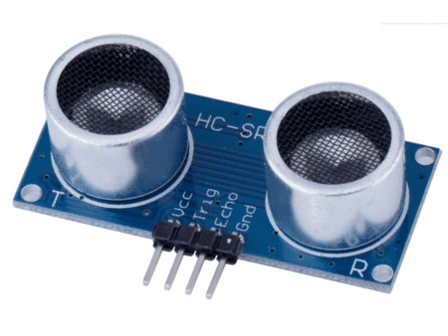

**6.3 Methane Gas MQ-4 Sensor**

MQ4 methane gas sensor is a MOS (metal oxide semiconductor) type sensor, used to detect the methane gas concentration within the air at either home or industries & generates output like analog voltage by reading it. Here, the range of concentration for sensing ranges from 300 pm – 10,000 ppm which is appropriate for the detection of a leak. This gas sensor mainly includes a detecting element like ceramic based on aluminum-oxide (Al₂O₃), coated with Tin dioxide (SnO2) and arranged within a stainless-steel mesh. When methane gas and detecting elements get in contact with each other then the resistivity of the detecting element will be changed. After that, the change is measured to get the methane gas concentration. The ignition of Methane gas is extremely exothermal which means it generates a huge amount of heat once ignited.

Pin1 (H Pins): These pins are two where one of them is used to connect supply and remaining pin is connected to ground

Pin2 (A Pins): Both the pins like A & B are interchangeable which will be connected to supply voltage.

Pin3 (B Pins): A & B pins are exchangeable where one pin acts like output and another pin will be pulled to the GND terminal. The pin configuration of the MQ-4 methane gas sensor module includes four pins which are discussed below.

VCC Pin: This pin provides voltage to the module and the typical operating voltage is +5V

GND Pin: This pin is used to connect the sensor module to the GND terminal of the system

DO (Digital Out) Pin: This pin provides digital output by setting a threshold value with the help of the potentiometer

AO (Analog Out): This pin provides output analog voltage which ranges from 0 to 5V depending on the intensity of gas.

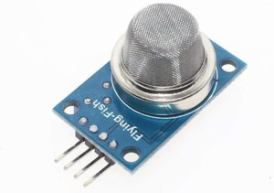

**6.4 Load Cell (HX711)**

A load cell converts a force into an electrical signal that can be measured. The electrical signal changes proportionally to the force applied. Strain gauge load cells are composed of a metal bar with attached strain gauges (under the white glue in the picture above). A strain gauge is an electrical sensor that measures force or strain on an object. Usually, load cells have four strain gauges hooked up in a Wheatstone bridge (as shown below) that allow us to get accurate resistance measurements. The wires coming from the load cell usually have the following colors:

Red: VCC (E+)

Black: GND (E-)

White: Output – (A-)

Green: Output + (A+)

The HX711 amplifier is a breakout board that allows you to easily read load cells to measure weight. You wire the load cell wires on one side, and the microcontroller on the other side. The HX711 communicates with the microcontroller using a two-wire interface (Clock and Data). You need to solder header pins on the GND, DT, SCK, and VCC pins to connect to the Arduino. I soldered the load cell wires directly to the E+, E-, A-, and A+ pins. The load cell wires were very thin and fragile, be careful when soldering to not damage the wires.

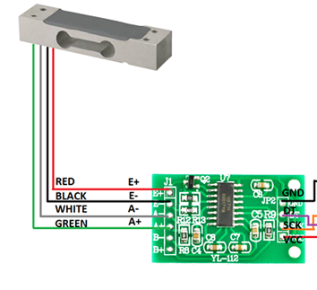

**6.5 LCD-I2C Display**

An I2C LCD display only uses two I/O pins that are not even part of the digital I/O pin set and can be shared with other I2C devices. A typical I2C LCD display consists of an HD44780-based character LCD display and an I2C LCD adapter. These LCDs are ideal for displaying only characters. A 16×2-characterLCD, for example, can display 32 ASCII characters across two rows. You can see tiny rectangles for each character on the screen as well as the pixels that make up a character. Each of these rectangles is a grid of 5×8 pixels. I2C LCD Adapter: At the heart of the adapter is an 8-bit I/O expander chip – PCF8574. This chip converts the I2C data from an Arduino into the parallel data required for an LCD display. The board also includes a tiny trimpot for making precise adjustments to the display’s contrast. There is a jumper on the board that provides power to the backlight. To control the intensity of the backlight, you can remove the jumper and apply external voltage to the header pin labeled ‘LED'. If you have multiple devices on the same I2C bus, you may need to set a different I2C address for the LCD adapter to avoid conflicting with another I2C device. For this purpose, the adapter comes with three solder jumpers/pads (A0, A1, and A2). The address is set when a jumper is shorted with a blob of solder.

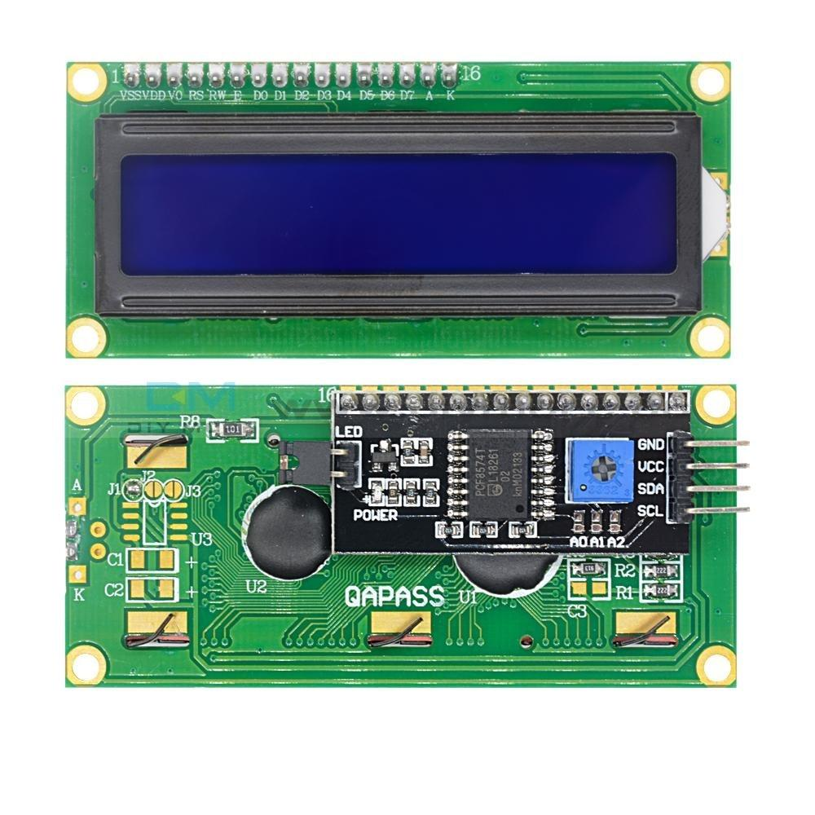

**6.6 Temperature (DHT11) Sensor**

DHT11 is a low-cost digital sensor for sensing temperature and humidity. This sensor can be easily interfaced with any micro-controller such as Arduino, Raspberry Pi etc… to measure humidity and temperature instantaneously. DHT11 sensor consists of a capacitive humidity sensing element and a thermistor for sensing temperature. The humidity sensing capacitor has two electrodes with a moisture holding substrate as a dielectric between them. The temperature range of DHT11 is from 0 to 50 degree Celsius with a 2-degree accuracy. The humidity range of this sensor is from 20 to 80% with 5% accuracy. The sampling rate of this sensor is 1Hz.i.e. it gives one reading for every second. DHT11 is small in size with operating voltage from 3 to 5 volts. The maximum current used while measuring is 2.5mA. DHT11 sensor has four pins- VCC, GND, Data Pin and a non-connected pin. A pull-up resistor of 5k to 10k ohms is provided for communication between sensor and micro-controller. This sensor is used in various applications such as measuring humidity and temperature values in heating, ventilation and air conditioning systems. Weather stations also use these sensors to predict weather conditions.

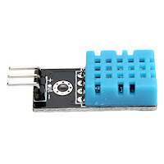

**6.7 SIM 900A GSM Module**

SIM900A Modem is built with Dual Band GSM/GPRS based SIM900A modem from SIMCOM. It works on frequencies 900/ 1800 MHz. SIM900A can search these two bands automatically. The frequency bands can also be set by AT Commands. The baud rate is configurable from 1200-115200 through AT command. The GSM/GPRS Modem is having internal TCP/IP stack to enable you to connect with the internet via GPRS. SIM900A is an ultra-compact and reliable wireless module. This is a complete GSM/GPRS module in a SMT type and designed with a very powerful single-chip processor integrating AMR926EJ-S core, allowing you to benefit from small dimensions and cost-effective solutions.

Specification:

Dual-Band 900/ 1800 MHz

GPRS multi-slot class 10/8GPRS mobile station class B

Compliant to GSM phase 2/2+

The module has two status pins which help to indicate two different kinds of status. The first one is the working status of the module and the second for communication status. Net status means either the module is connecting to the network or other network functions, etc. Both these pins can’t operate LED directly. They always act with a combination of a transistor.

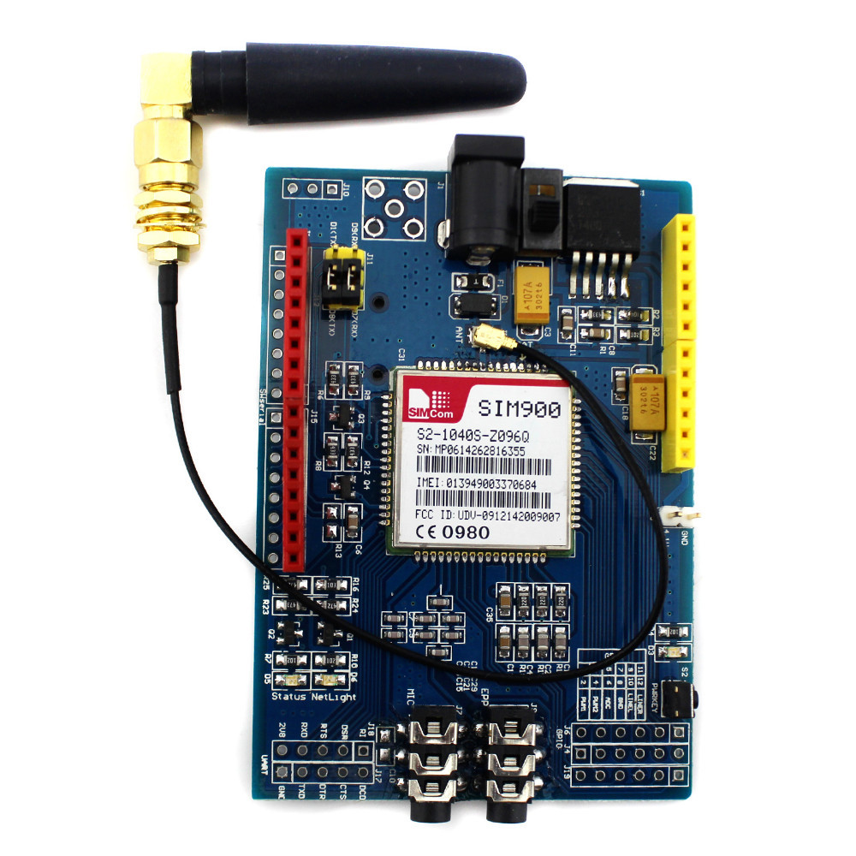

**6.8 Servo Motor**

A servo motor is a type of motor that can rotate with great precision. Normally this type of motor consists of a control circuit that provides feedback on the current position of the motor shaft, this feedback allows the servo motors to rotate with great precision. If you want to rotate an object at some specific angle or distance, then you use a servo motor. It is just made up of a simple motor which runs through a servo mechanism. If a motor is powered by a DC power supply, then it is called DC servo motor, and if it is AC-powered motor then it is called AC servo motor. A servo motor usually comes with a gear arrangement that allows us to get a very high torque servo motor in small and lightweight packages. Due to these features, they are being used in many applications like toy car, RC helicopters and planes, Robotics, etc. Servo motors are rated in kg/cm (kilogram per centimeter) most hobby servo motors are rated at 3kg/cm or 6kg/cm or 12kg/cm. This kg/cm tells you how much weight your servo motor can lift at a particular distance. Servos have three wires coming out of them. Out of which two will be used for Supply (positive and negative) and one will be used for the signal that is to be sent from the MCU. All servo motors work directly with your +5V supply rails but we have to be careful on the amount of current the motor would consume. Servo motor is controlled by PWM (Pulse with Modulation) which is provided by the control wires. There is a minimum pulse, a maximum pulse and a repetition rate. Servo motor can turn 90 degrees from either direction form its neutral position. The servo motor expects to see a pulse every 20 milliseconds (ms) and the length of the pulse will determine how far the motor turns.

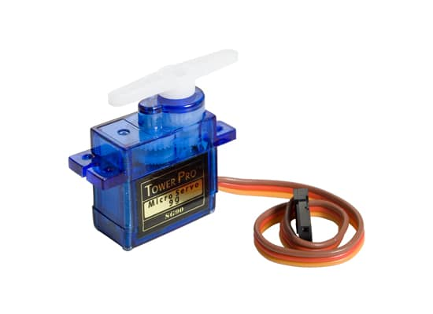

**6.9 Peltier Kit**

The Thermoelectric Peltier Refrigeration Cooling System kit is a semiconductor cooling kit which uses a TEC1-12706 Thermoelectric Cooler 6A Peltier Module. The kit has 2 heat sinks: the bigger one is for the hotter side and the smaller one is for the cooler side. The bigger the heat sink, the greater the dissipation of the heat. The fan, also included in this kit, acts as a radiator. This is attached to the bigger heat sink. The TEC1-12706 thermoelectric Peltier module is sandwiched between the two heat sinks. The module will reduce the temperature. The kit when assembled takes up less space and is ideal for Pet Space air conditioning (dogs house, chicken, etc.), small refrigerator.

Features:

Using GL style of the refrigerator, effectively releases the thermal deformation ability of the refrigerator produce at work. Small volume does not occupy space, installation is simple. This semiconductor cooler is a form of solid-state cooling that incorporates both semiconductor technologies and electronic assembly techniques. It can be used as a Pet Air Conditioner or a little fridge. They offer advantages such as compact size, quiet operation, and precise temperature control, making them a versatile solution for both cooling and heating needs. However, they also have limitations, such as relatively low efficiency compared to traditional refrigeration methods and the need for adequate heat dissipation to prevent overheating.

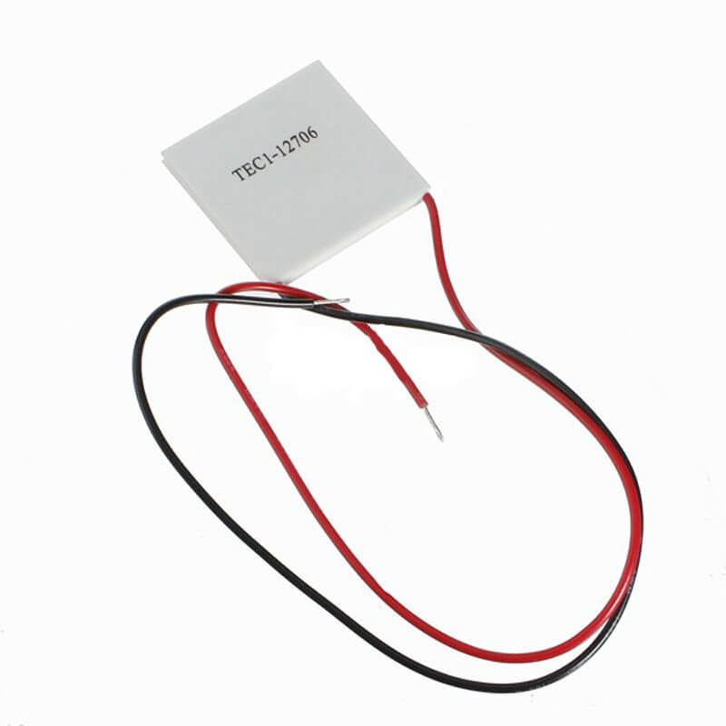

**Chapter 7**

**SOFTWARE USED**

Here we have programmed Arduino Uno in C language. Arduino IDE 1.8.19 open-source software is used to write the code and upload it to the board. Arduino uses its own language to program Arduino boards. Its programming language is easy to understand. Arduino IDE (Integrated Development Environment) is a software platform used primarily for writing, compiling, and uploading code to Arduino microcontroller boards. It's a crucial tool for hobbyists, students, educators, and professionals working on a wide range of projects, from simple blinking to complex robotic systems. Arduino IDE plays a central role in the Arduino ecosystem, empowering users to unleash their creativity and bring their ideas to life through programming and electronics. Its simplicity, versatility, and extensive community support make it an indispensable tool for anyone interested in exploring the world of physical computing and DIY electronics. One of the most valuable features of Arduino IDE is the Serial Monitor, which allows users to communicate with their Arduino boards in real-time. The heart of Arduino IDE is its code editor, where users write programs in the Arduino programming language, which is a simplified version of C/C++. The editor provides syntax highlighting, auto-indentation, and basic code completion to aid in writing clean and error-free code. Arduino IDE is available for Windows, macOS, and Linux, making it accessible to users on different operating systems. This cross-platform compatibility ensures that Arduino developers can work seamlessly regardless of their preferred computing environment.



**Chapter 8**

**COST ESTIMATION**

|  |  |
| --- | --- |
| Arduino UNO | 600 |
| Temperature Sensor | 200 |
| Ultrasonic Sensor | 250 |
| MQ-4 Sensor | 350 |
| Load Cell-HX711 (2) | 500 |
| Peltier Kit | 1000 |
| LCD+I2C Display | 450 |
| Servo Motor | 200 |
| GSM-900A Module | 1000 |
| Jump wire, Adapter, Battery | 500 |
| Body Of Refrigerator | 800 |
| Additional Expenses | 550 |
| **TOTAL** | **6400** |

Table 8.1 Cost Estimation

**Chapter 9**

**RESULTS**

Implemented ultrasonic sensor with servo motor for the functioning of automatic door. Implemented DHT11 sensor for detecting temperature inside the refrigerator. Implemented MQ4 sensor for the detection of food spoilage. Implemented 2 LOAD CELL for the functioning of food storage. Implemented GSM module to transmit the alert message to the user.

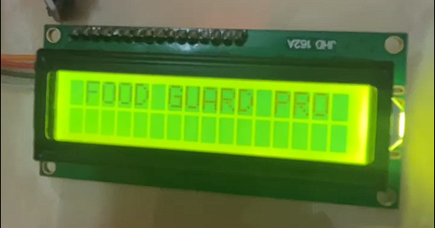

Fig 9.1 Introduction Message

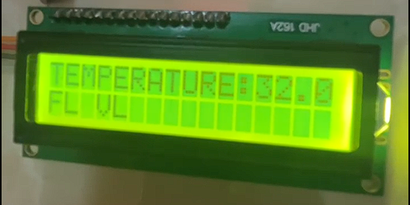

Fig 9.2 Main Interface

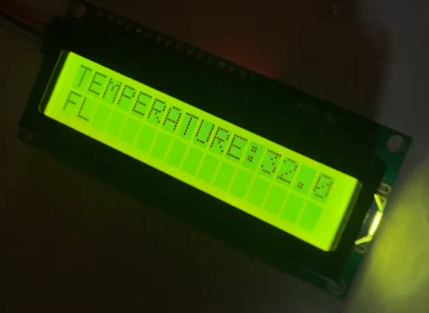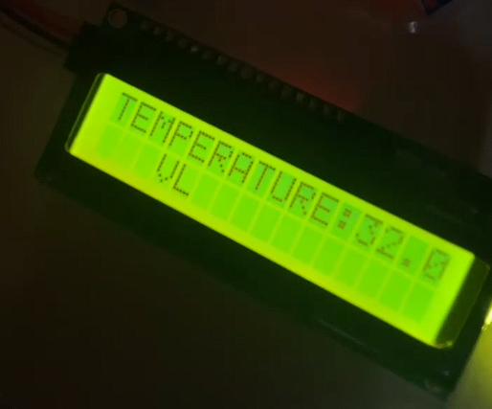

Fig 9.3 Food Storage Display

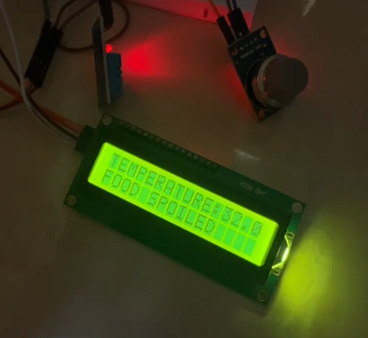

Fig 9.4 Food Spoilage Display

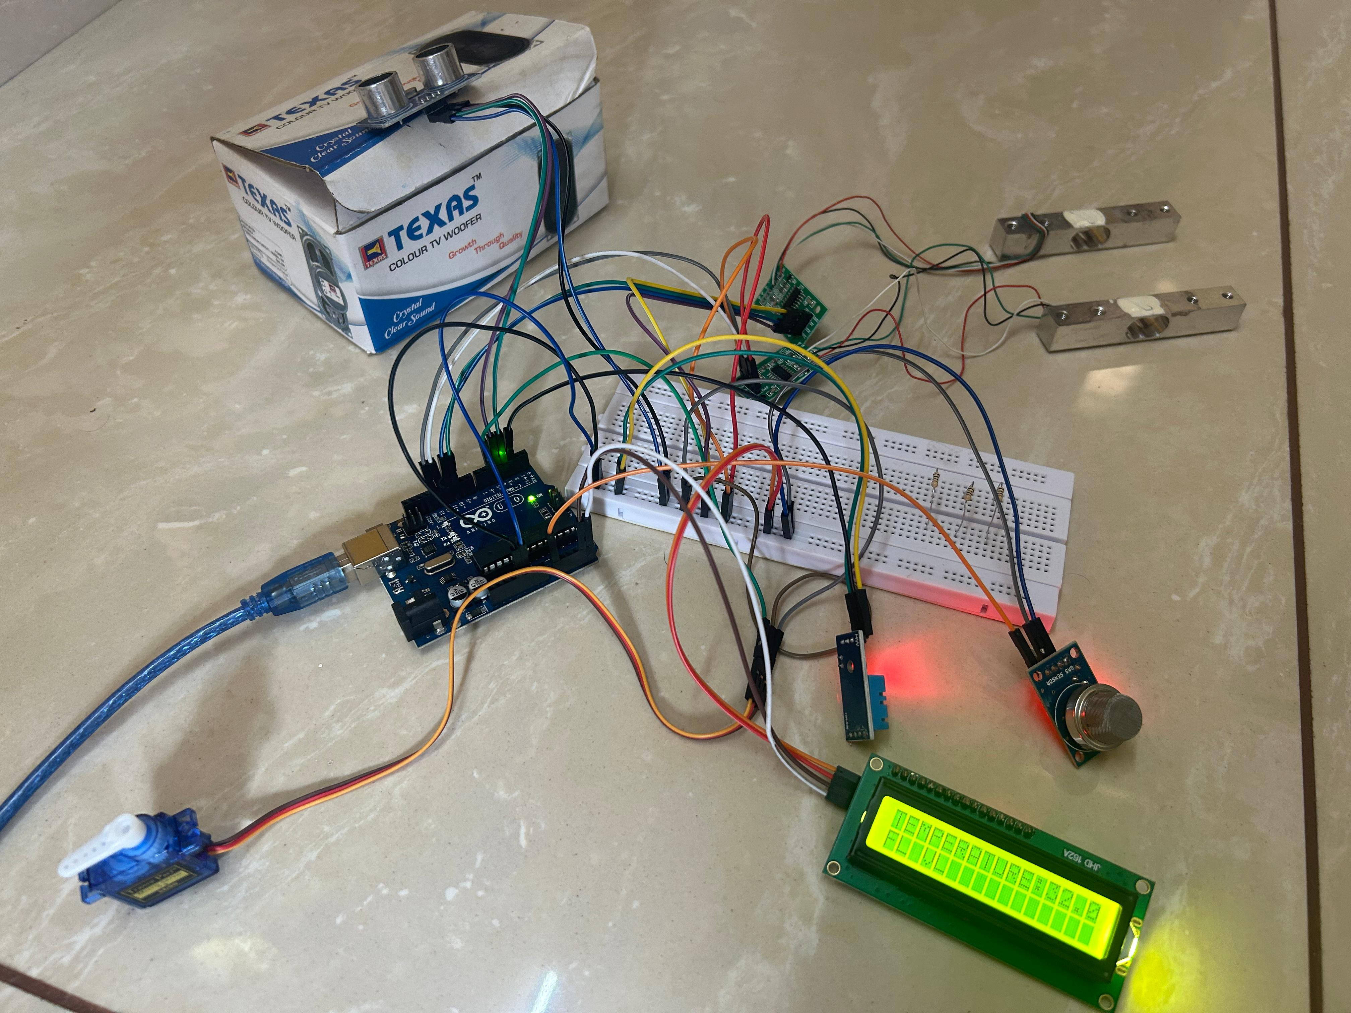

Fig 9.5 Project Wiring

**Chapter 10**

**CONCLUSION**

Our prototype is useful in detecting methane levels from open food items as well as notifying about expiring packed food items. Smart refrigerators are economically cost effective, and user friendly. Automatic doors make the use of refrigerator easier. Also, the portable feature makes it easy for anyone to carry it anywhere with power supply. The smart refrigerator with food spoilage detection, food storage detection, automatic door, and portability features represents a significant advancement in home appliance technology. It not only enhances food safety and convenience but also offers flexibility and sustainability benefits, making it an indispensable asset in modern households. The integration of food spoilage detection technology ensures that consumers can trust their refrigerator to maintain food safety standards. By detecting spoiled food early, it minimizes the risk of foodborne illnesses and reduces food waste. The compact design of the smart refrigerator offers portability options, making it suitable for various living arrangements such as small apartments, dormitories, or even as a secondary refrigerator in larger households. Its versatility allows consumers to adapt to changing living situations without compromising on functionality. The automatic door mechanism adds a layer of convenience to users' daily lives by allowing hands-free access to the refrigerator. This feature is particularly useful in busy kitchens or for individuals with mobility issues, enhancing accessibility and usability. The incorporation of AI and IoT technologies in the smart refrigerator opens possibilities for future innovations and enhancements. As these technologies continue to evolve, the refrigerator can evolve with them, offering even more advanced features and capabilities to meet the changing needs of consumers.

**Chapter 11**

**REFERENCES**

[1] Gupta, S., Giri, S., Srivastava, T., Agarwal, P., Sharma, R., & Agrawal, A. (2021). Smart Refrigerator based on “Internet of Things.” 2021 International Conference on Advance Computing and Innovative Technologies in Engineering (ICACITE). doi:10.1109/icacite51222.2021.940

[2] Nasir, H., Aziz, W. B. W., Ali, F., Kadir, K., & Khan, S. (2018). The Implementation of IoT Based Application Smart Refrigerator System. 2018 2nd International Conference on Smart Sensors and (ICSSA). doi:10.1109/icssa.2018.8535867 10.1109/ICSSA.2018.8535867

[3] Chaudhari, V., Kulkarni, M., Sakpal, S., Ubale, A., & Sangale, A. (2018). EcoFriendly Refrigerator Using Peltier Device. 2018 International Conference on Communication and Signal Processing (ICCSP). doi:10.1109/iccsp.2018.8524414

[4] Guruler, H. (2015). The design and implementation of a GSM based user machine interacted refrigerator. 2015 International Symposium on Innovations in Intelligent SysTems and Applications (INISTA). doi:10.1109/inista.2015.7276719 101109/INISTA20157276719

[5] K. Umamaheswari, M. Susneha and B. S. Kala, "IoT based Smart Cold Storage System for Efficient Stock Management," 2020 International Conference on Communication and Signal Processing (ICCSP), Chennai, India, 2020, pp. 0051-0055, doi: 10.1109/ICCSP48568.2020.9182426. keywords